1 As you've noted, the lab page has one primary script: When the page loads, it attachesa click handler to all the buttons that brings up an alert box. Rewrite the handler so that the contents of the alert box contain the name of thebutton,rather than identical text.

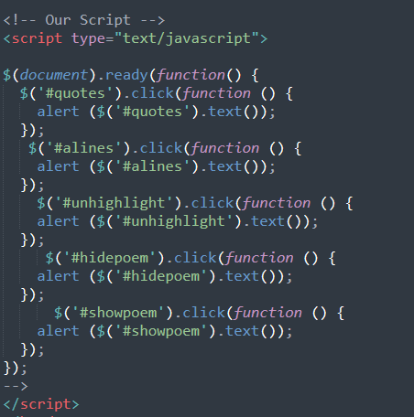

2

1. Script the Highlight Quotes button to highlight all of the quotes in the document
2. You may have noted that there are three quotes in the document: TwoinJabberwocky and one elsewhere. Rewrite the script so that it only highlightsthequotes within the poem

5 One task we may consider in our project is allowing the user to see a quickoverviewof days that meet a particular criteria. We wll simulate that task by assigningclassestoparticular days in a table

1. Script the Education button so that it highlights all of the days in the calendarwithclass Education.



1. Script the Miscellaneous button so that it highlights all of the days inthecalendarwith class Miscellaneous.



1. In case you haven't done so already, make sure that both scripts unhighlight daysbefore highlighting them.

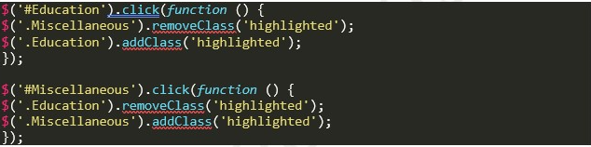

7 Script the cells of the calendar so that when the user hovers over a cell, thecell getshighlighted and the tags for the cell appear.

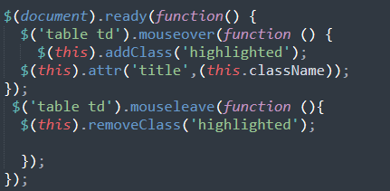

Output

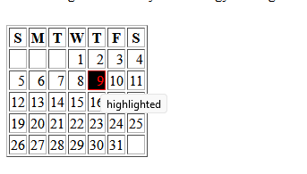

8 As you no doubt have noted, finding the right selector is an important part of scripting with jQuery. Let's write a tool that helps us easily verify whether a selector we’ve chosen selects the appropriate part of the page

a) Script the Select button. Try it with a variety of selectors.

b) Script the Unselect All button.

c) Script the Hide and Show buttons, which should hide or show the text intermediate selector field.

